|  |  |
| --- | --- |
|  | **CSC1106 Web Programming  Tutorial Plus 05 Bootstrap** |

**Introduction**

In this tutorial exercise, we will learn using the video tutorial “Learn How to Code Using Bootstrap 5 Tutorial 2023!” by Coding With JayBird (<https://www.youtube.com/watch?v=g9b4LjYrsUQ>).

**Exercises**

1. Watch the video tutorial linked above.
2. Design an administrator portal using Bootstrap as illustrated below.

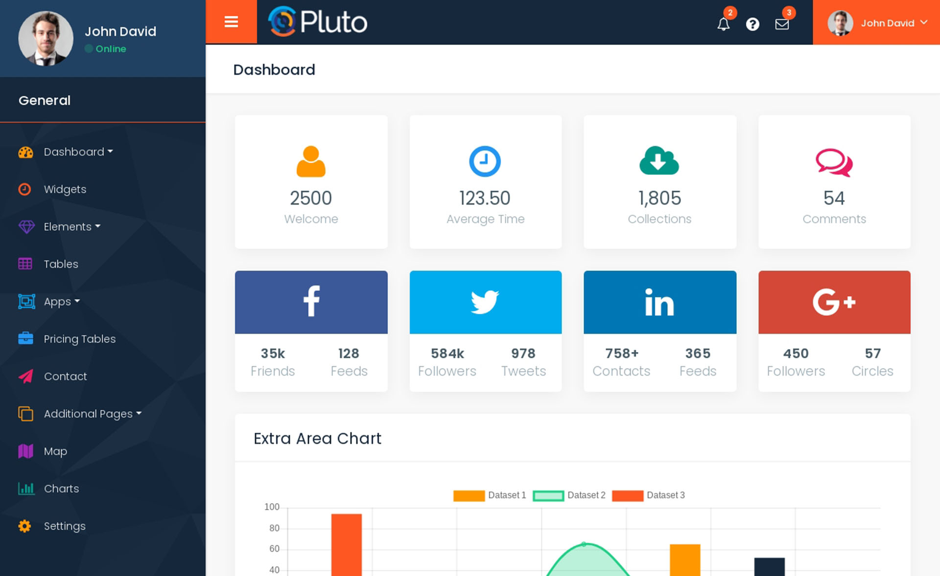  
Source: ThemeWagon

**Remarks:**

You are not required to use the exact color tones, icons, images, or design elements shown in the illustration. The goal of this exercise is to program a **user interface layout** purely through coding, without using UI software tools.

**Submission**

After completion, provide the following evidence for participation marks.

Screenshots of the Bootstrap administrator portal interface design.

Paste the screenshots in the space below.

This is an individual work.

Please rename this Microsoft Word tutorial+ file to “tuto_plus_05_bootstrap_[SIT-SID].docx”, replacing [SIT-SID] with your SIT student ID. Submit the file to the corresponding Dropbox before the due date.

=== Happy Programming ===

**Screenshots of the Bootstrap administrator portal interface design.**

